Day 2 of Network Analysis

1. 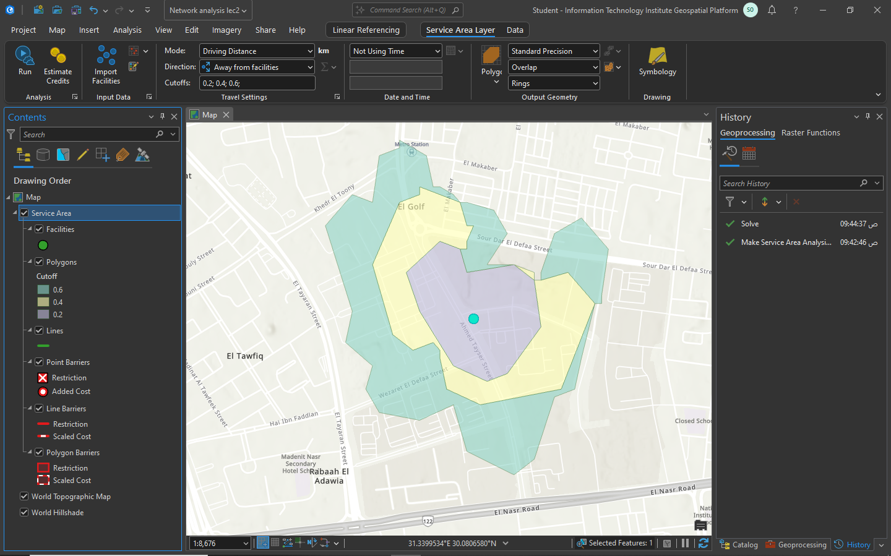ISI service area 0.2 0.4 0.6 km
2. Tring split and dissolve

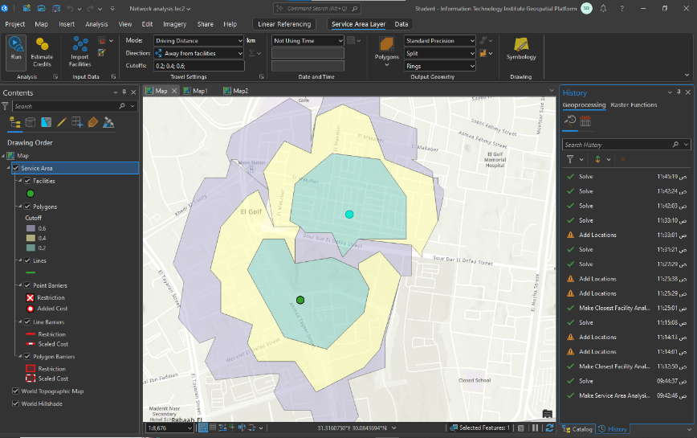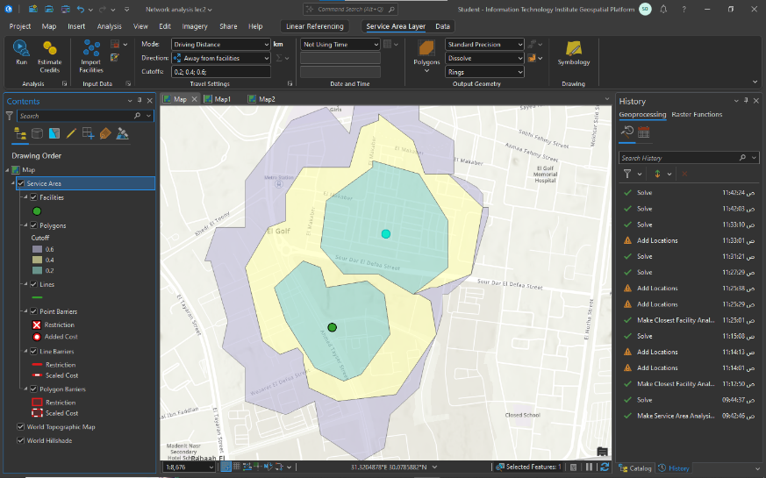dissolve split

1. 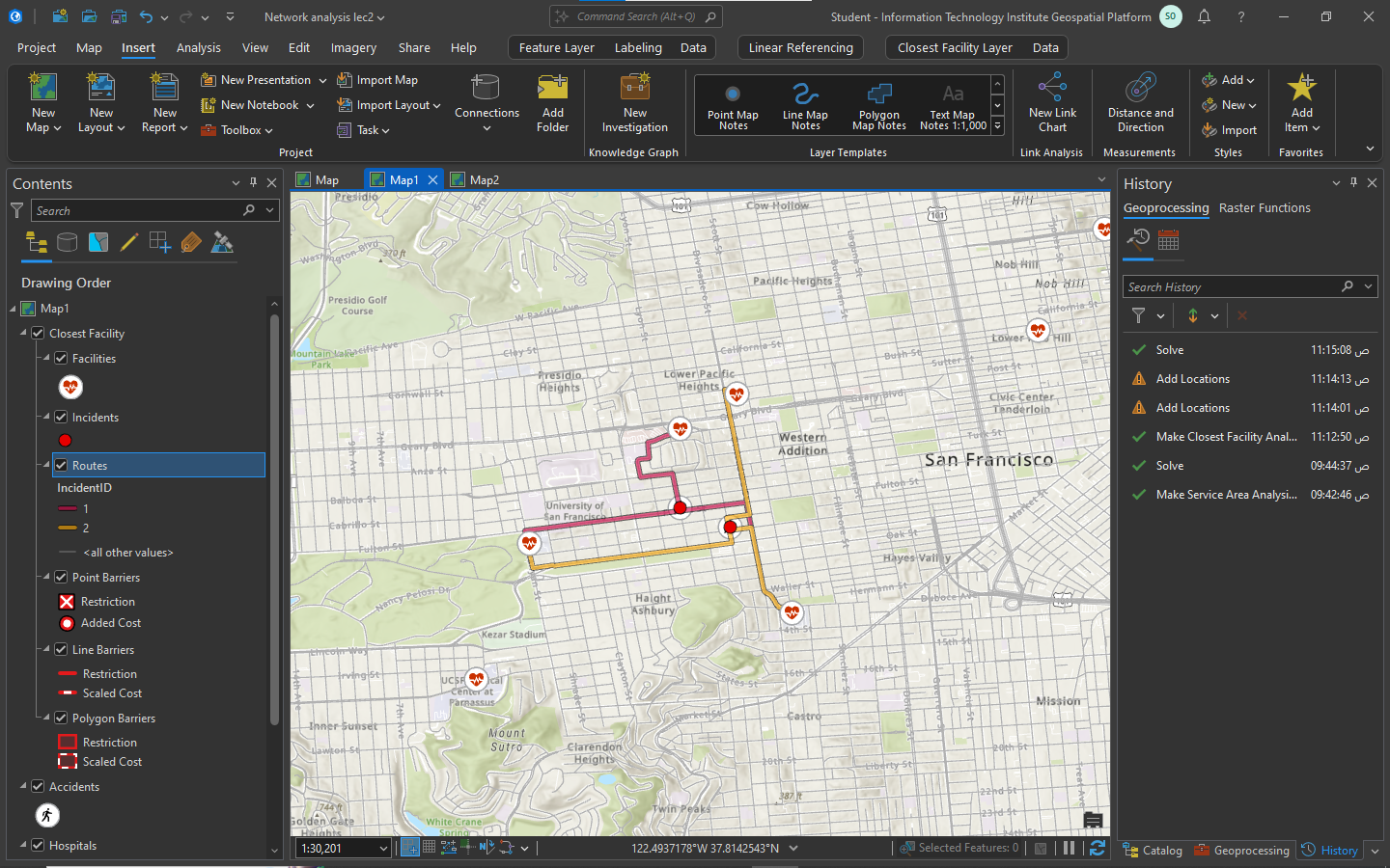Closest facility solver Task
2. 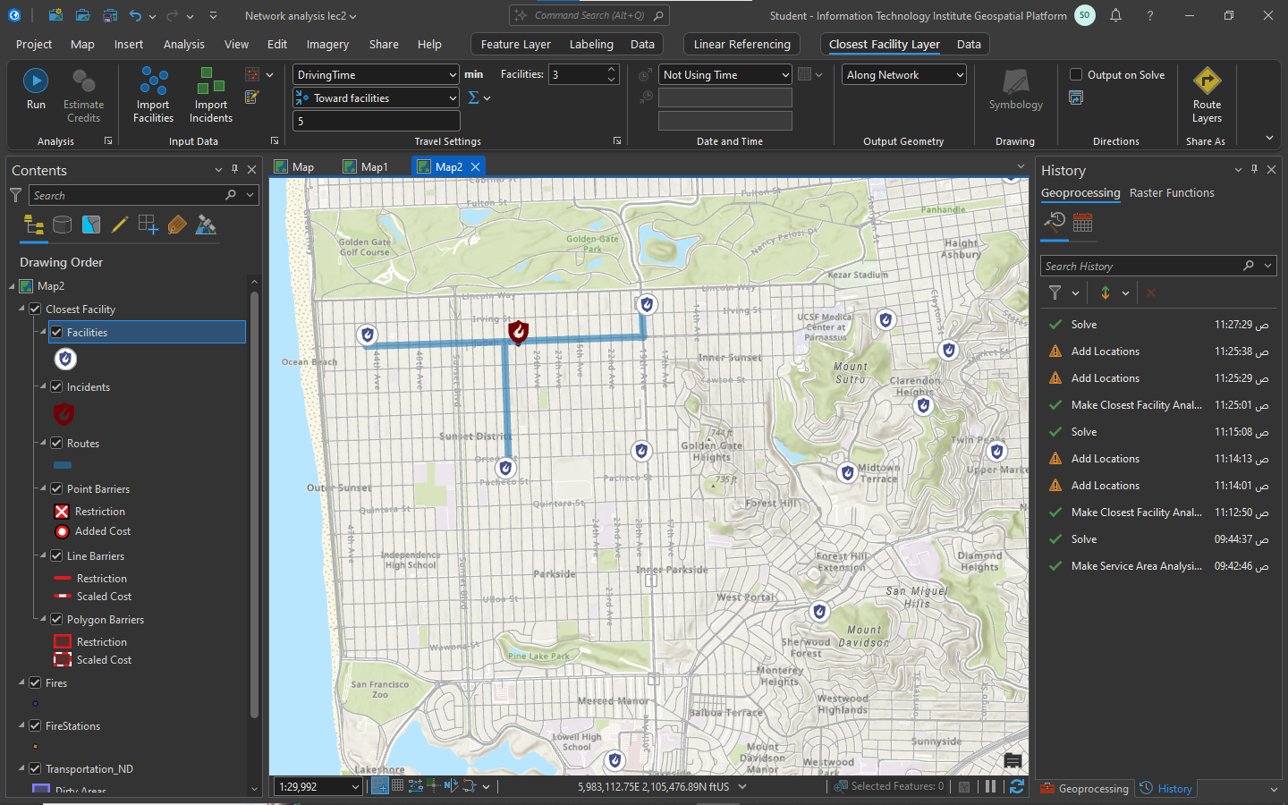Fire places closest fire station before the barrier for festivals
3. 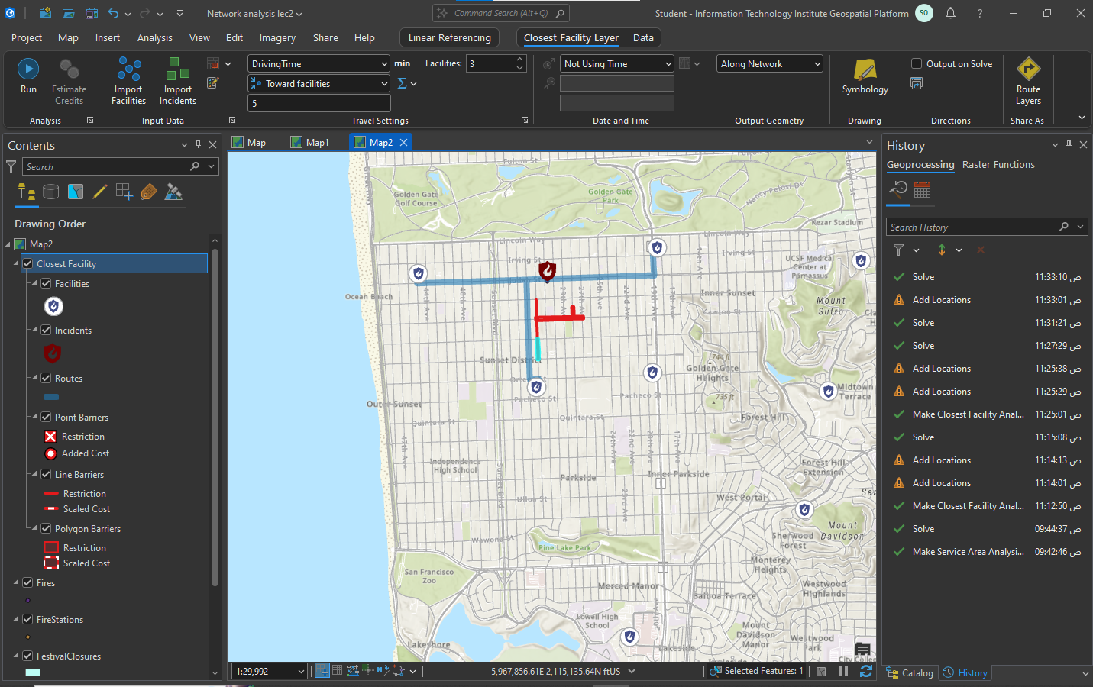Fire places closest fire station after the barrier for festivals
4. 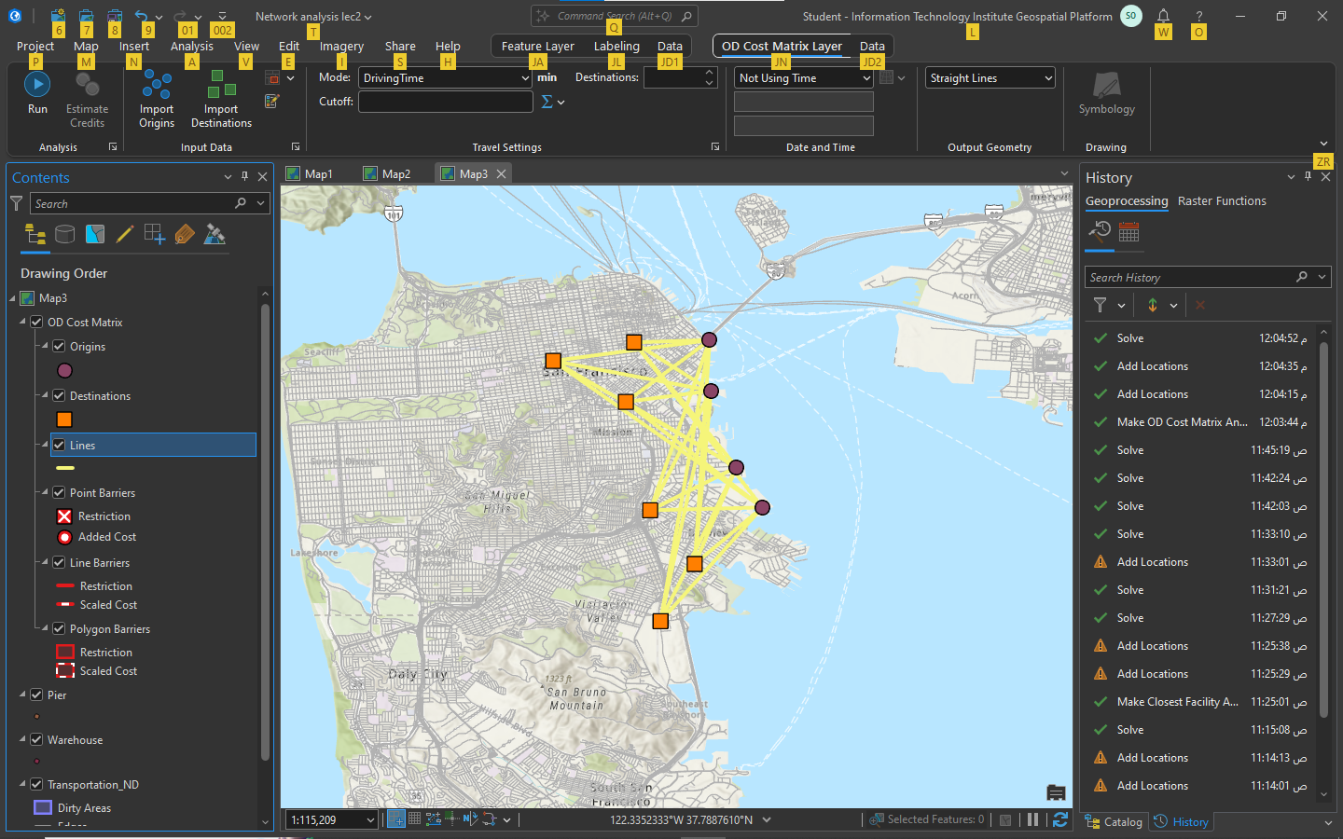ODC pier and warehouses des not set
5. 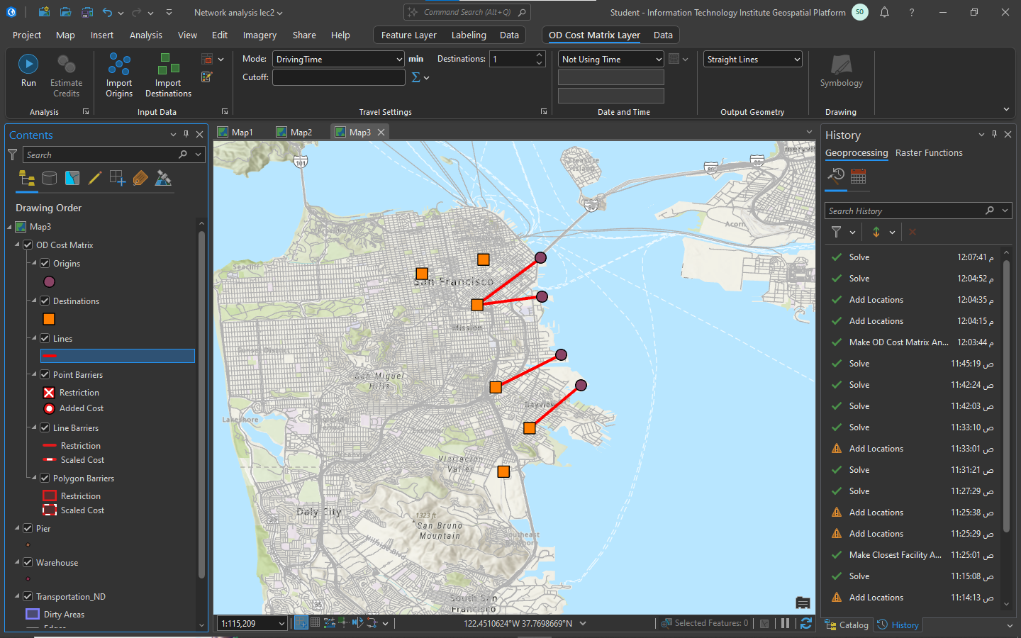ODC pier and warehouses des =1
6. 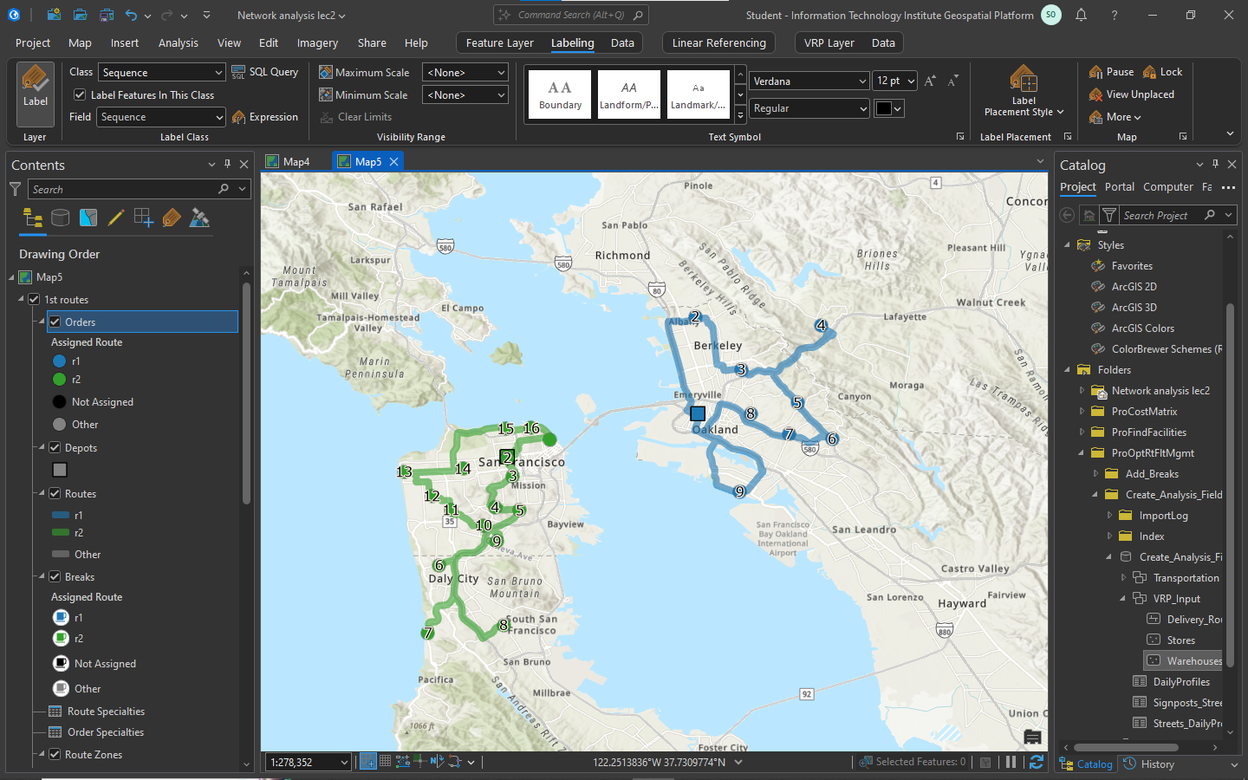VRP downtown and east bay routs
7. VRP downtown and bay routes after and before stops and breaks

